Tutorial 1 Getting started with Iris
This tutorial shows how to setup and use Colab with google account with SciKit-Learn via the Iris dataset.

Set up a google account
To sign up for Colab, create a Google Account. You can use the username and password to sign in to Colab and other Google products like Google Drive.
- Go to the Google Account creation page.
- Follow the steps on the screen to set up your account.
- Use the account you created to sign in to Colab.

Text guide:
https://support.google.com/accounts/answer/27441?hl=en
Video guide:
https://www.youtube.com/watch?v=ArZpwBl_z10
Special needs:
Let us know and we can set up an account for you.

Welcome to Colab
https://colab.research.google.com/

To start working with Colab you first need to log in to your google account, then go to this link https://colab.research.google.com.

Create a new Jupyter notebook by clicking New Notebook at the bottom right corner or from the top tabs for other sources.
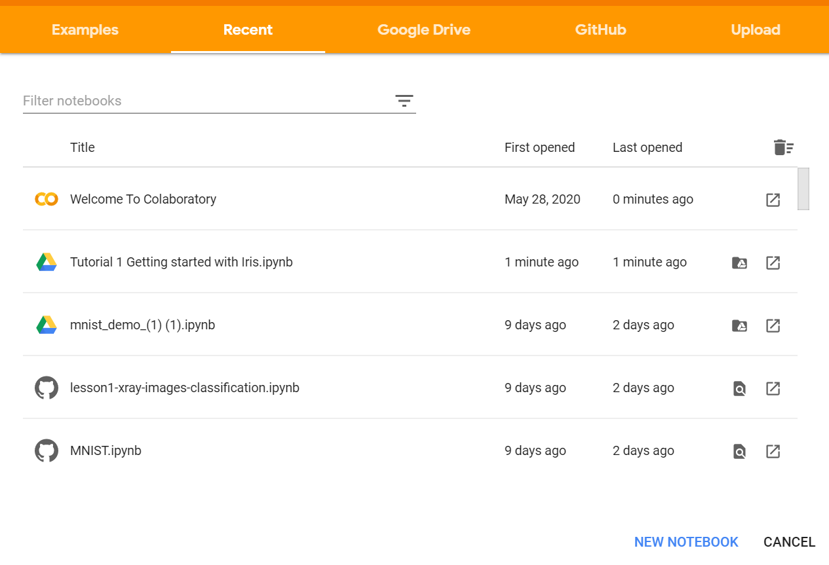

On creating a new notebook, it will create a Jupyter notebook with Untitled0.ipynb and save it to your google drive in a folder named Colab Notebooks. Now as it is essentially a Jupyter notebook, all commands of Jupyter notebooks will work here. If you haven’t use Jupyter notebooks before, you can refer the details in Getting started with Jupyter Notebook.
This is the line where you can change the file name.
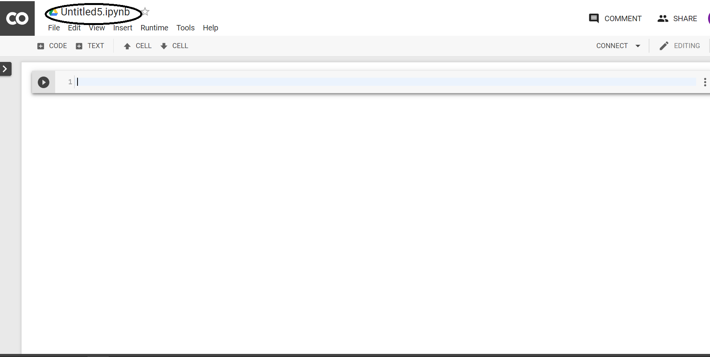

Change Runtime Environment:
Click the “Runtime” dropdown menu. Select “Change runtime type”. Select “Runtime type” dropdown menu.
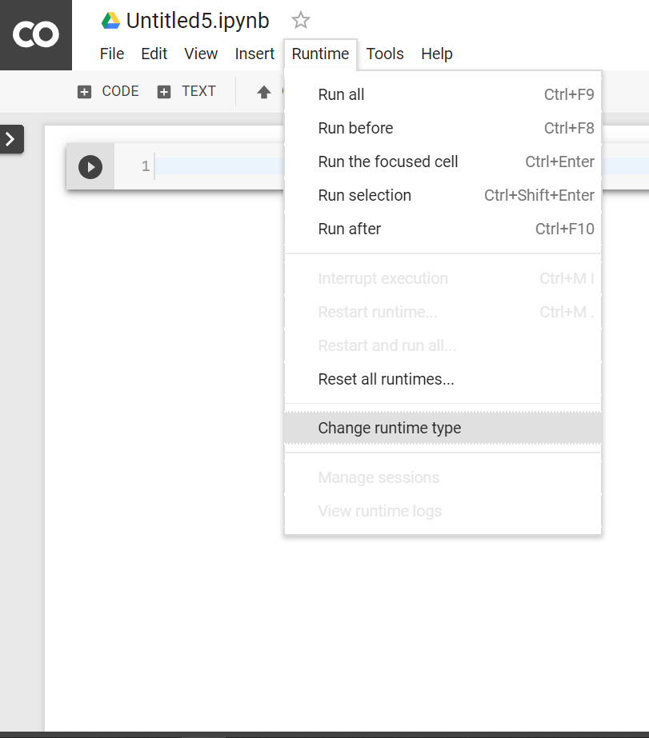

Use GPU:
Click the “Runtime” dropdown menu. Select “Change runtime type”. Now select GPU in the “Hardware accelerator” dropdown menu. 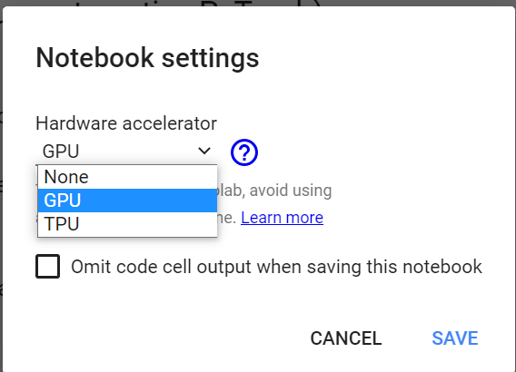
Verify GPU:
import tensorflow as tf
tf.test.gpu_device_name()

If gpu is connected it will output following:

'/device:GPU:0'
Otherwise, it will output following:
..
Video guide:
https://www.youtube.com/watch?v=inN8seMm7UI

It is a good idea to make sure your environment was installed successfully and is working as expected.
The script below will help you test out your environment. It imports each library required in this tutorial and prints the version.

# Check the versions of libraries

# Python version
import sys
print('Python: {}'.format(sys.version))
# scipy
import scipy
print('scipy: {}'.format(scipy.__version__))
# numpy
import numpy
print('numpy: {}'.format(numpy.__version__))
# matplotlib
import matplotlib
print('matplotlib: {}'.format(matplotlib.__version__))
# pandas
import pandas
print('pandas: {}'.format(pandas.__version__))
# scikit-learn
import sklearn
print('sklearn: {}'.format(sklearn.__version__))

# Load libraries
from pandas import read_csv
from pandas.plotting import scatter_matrix
from matplotlib import pyplot
from sklearn.model_selection import train_test_split
from sklearn.model_selection import cross_val_score
from sklearn.model_selection import StratifiedKFold
from sklearn.metrics import classification_report
from sklearn.metrics import confusion_matrix
from sklearn.metrics import accuracy_score
from sklearn.linear_model import LogisticRegression
from sklearn.tree import DecisionTreeClassifier
from sklearn.neighbors import KNeighborsClassifier
from sklearn.discriminant_analysis import LinearDiscriminantAnalysis
from sklearn.naive_bayes import GaussianNB
from sklearn.svm import SVC

The result should show something similar to the picture below.
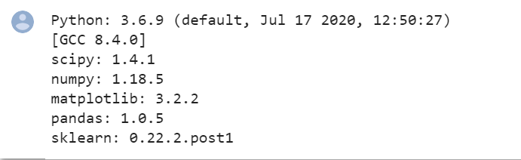

Knowing your dataset
Now it is time to take a look at the data.
In this step we are going to take a look at the data a few different ways:
- Dimensions of the dataset.
- Peek at the data itself.
- Statistical summary of all attributes.
- Breakdown of the data by the class variable.

# summarize the data
from pandas import read_csv
# Load dataset
url = "https://raw.githubusercontent.com/qwuae1/MachineLearning/master/iris.csv"
names = ['sepal-length', 'sepal-width', 'petal-length', 'petal-width', 'class']
dataset = read_csv(url, names=names)
# shape
print(dataset.shape)
# head
print(dataset.head(20))
# descriptions
print(dataset.describe())
# class distribution
print(dataset.groupby('class').size())

The result should show something similar to the picture below.

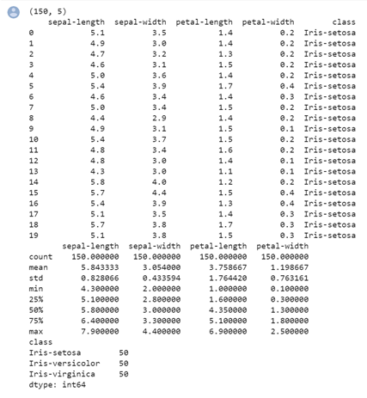

Visualizing your data
We are going to look at two types of plots:
- Univariate plots to better understand each attribute.
- Multivariate plots to better understand the relationships between attributes.
# visualize the data
from pandas import read_csv
from pandas.plotting import scatter_matrix
from matplotlib import pyplot
# Load dataset
url = "https://raw.githubusercontent.com/jbrownlee/Datasets/master/iris.csv"
names = ['sepal-length', 'sepal-width', 'petal-length', 'petal-width', 'class']
dataset = read_csv(url, names=names)
# box and whisker plots
dataset.plot(kind='box', subplots=True, layout=(2,2), sharex=False, sharey=False)
pyplot.show()
# histograms
dataset.hist()
pyplot.show()
# scatter plot matrix
scatter_matrix(dataset)
pyplot.show()

The result should show something similar to the picture below.
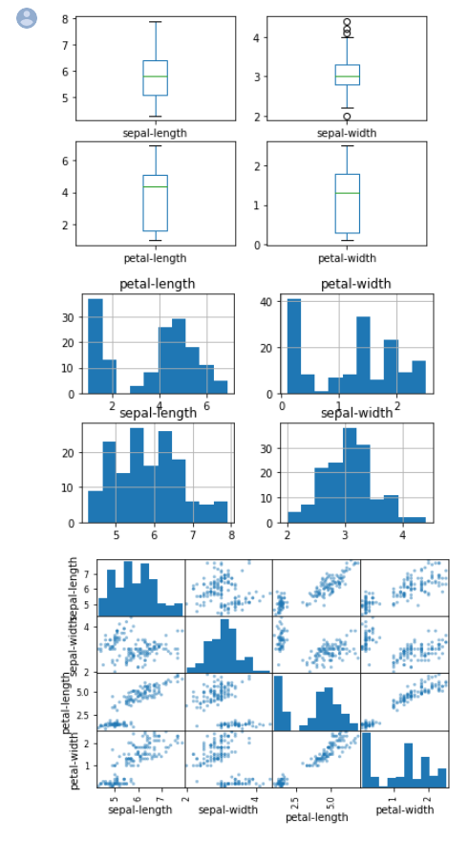

Training with Algorithms
Here is what we are going to cover in this step:
- Separate out a validation dataset.
- Set-up the test harness to use 10-fold cross validation.
- Build multiple different models to predict species from flower measurements
- Select the best model.
# compare algorithms
from pandas import read_csv
from matplotlib import pyplot
from sklearn.model_selection import train_test_split
from sklearn.model_selection import cross_val_score
from sklearn.model_selection import StratifiedKFold
from sklearn.linear_model import LogisticRegression
from sklearn.tree import DecisionTreeClassifier
from sklearn.neighbors import KNeighborsClassifier
from sklearn.discriminant_analysis import LinearDiscriminantAnalysis
from sklearn.naive_bayes import GaussianNB
from sklearn.svm import SVC
# Load dataset
url = "https://raw.githubusercontent.com/qwuae1/MachineLearning/master/iris.csv"
names = ['sepal-length', 'sepal-width', 'petal-length', 'petal-width', 'class']
dataset = read_csv(url, names=names)
# Split-out validation dataset
array = dataset.values
X = array[:,0:4]
y = array[:,4]
X_train, X_validation, Y_train, Y_validation = train_test_split(X, y, test_size=0.20, random_state=1, shuffle=True)
# Spot Check Algorithms
models = []
models.append(('LR', LogisticRegression(solver='liblinear', multi_class='ovr')))
models.append(('LDA', LinearDiscriminantAnalysis()))
models.append(('KNN', KNeighborsClassifier()))
models.append(('CART', DecisionTreeClassifier()))
models.append(('NB', GaussianNB()))
models.append(('SVM', SVC(gamma='auto')))
# evaluate each model in turn
results = []
names = []
for name, model in models:
kfold = StratifiedKFold(n_splits=10, random_state=1, shuffle=True)
cv_results = cross_val_score(model, X_train, Y_train, cv=kfold, scoring='accuracy')
results.append(cv_results)
names.append(name)
print('%s: %f (%f)' % (name, cv_results.mean(), cv_results.std()))
# Compare Algorithms
pyplot.boxplot(results, labels=names)
pyplot.title('Algorithm Comparison')
pyplot.show()
The result should show something similar to the picture below.

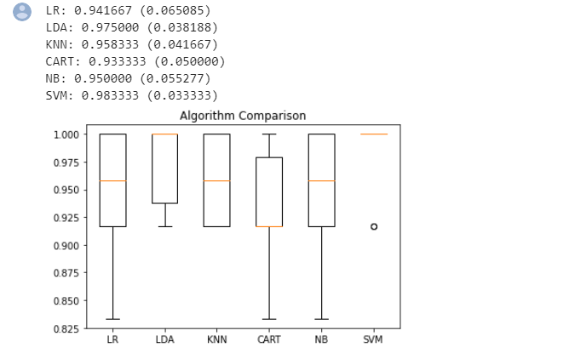

Testing Predictions
# make predictions
from pandas import read_csv
from sklearn.model_selection import train_test_split
from sklearn.metrics import classification_report
from sklearn.metrics import confusion_matrix
from sklearn.metrics import accuracy_score
from sklearn.svm import SVC
# Load dataset
url = "https://raw.githubusercontent.com/qwuae1/MachineLearning/master/iris.csv"
names = ['sepal-length', 'sepal-width', 'petal-length', 'petal-width', 'class']
dataset = read_csv(url, names=names)
# Split-out validation dataset
array = dataset.values
X = array[:,0:4]
y = array[:,4]
X_train, X_validation, Y_train, Y_validation = train_test_split(X, y, test_size=0.20, random_state=1)
# Make predictions on validation dataset
model = SVC(gamma='auto')
model.fit(X_train, Y_train)
predictions = model.predict(X_validation)
# Evaluate predictions
print(accuracy_score(Y_validation, predictions))
print(confusion_matrix(Y_validation, predictions))
print(classification_report(Y_validation, predictions))

The result should show something similar to the picture below.

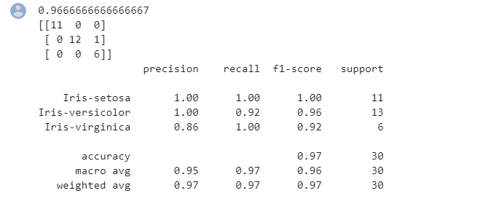

Sample output

Setup

Knowing your dataset
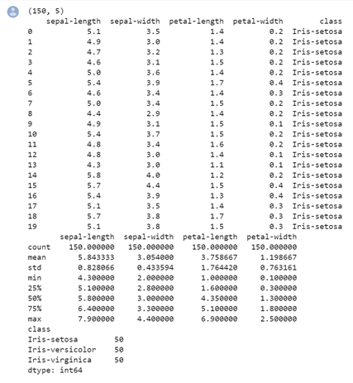

Visualizing your data

Training with Algorithms

Testing Predictions

